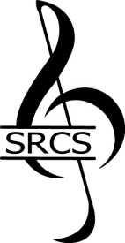
STAFFORD REGIONAL CHORAL SOCIETY
2026 Music Scholarship Recommendation
Thank you for taking time to share your thoughts and comments about this applicant. Your recommendation will be invaluable to our efforts in choosing a scholarship recipient.
Submission deadline: January 23, 2026 Auditions will be held: January 31, 2026

Applicant Name:

Your Name:

Phone:
Email:

How do you know the applicant? __________________________________________________________________________
Please tell us about the applicant.

Please email your completed recommendation to our Artistic Director, Anola Douglas, at: adouglas13@gmail.com

Thank you!

